Implementation Report
for
Telecom Customers Churn Prediction System
Prepared by
 | Names | Registration Number | Signature
1 | KYANZI HASSAN MUSISI | 17/U/19979/EVE
2 | WAMALA EDGAR WATSON | 17/U/20633/EVE
3 | KASOZI JAFFAR | 17/U/4741/EVE
4 | BWAYO JOEL | 17/U/3777/EVE

Makerere University
August 2019

A graph showing the Churn against Value_counts.
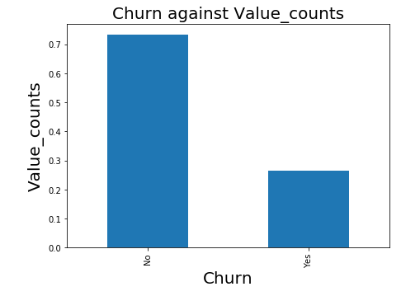

Insight
We started by analyzing our target variable Churn. It was plotted against its Value_counts in the Data set. It shows that at least 70% of the customers did not leave and about 30% left.
We did proceed with comparing churn and other data set features to see the impact as shown below;
The graph customers contracts against churn.

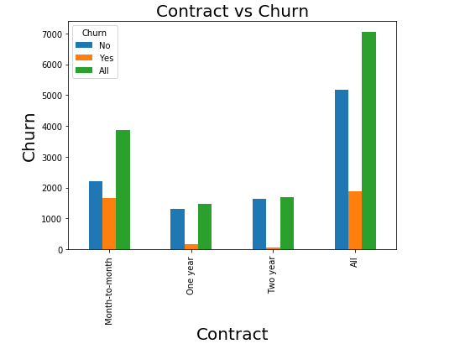

Insight.
The percentage of Month-to-month contract clients that left the company is 88.55% which is high.
The percentage of One year contract clients that left the company is 8.88% which is slight.
The percentage of Two year contract clients that left the company 2.56% which is the smallest.
Recommendations.
Therefore the company should find means of retaining monthly clients as these are most likely subject to attrition or churn.

The graph shows InternetService versus Churn.
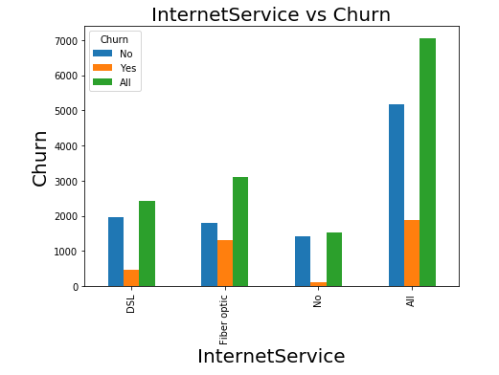

Insight.
The percentage of clients that left and used DSL as an Internet Service is 24.55%.
The percentage of clients that left and used Fiber optic as an Internet Service is 69.39% which is high.
The percentage of clients that used no Internet Service that churned is 6.05%.
Fiber optic clientele is the highest which may be due to poor customer service and high costs.
Recommendations.
The company should reduce costs on implementation and maintenance of fiber optic.
The graph showing different payment methods against Churn

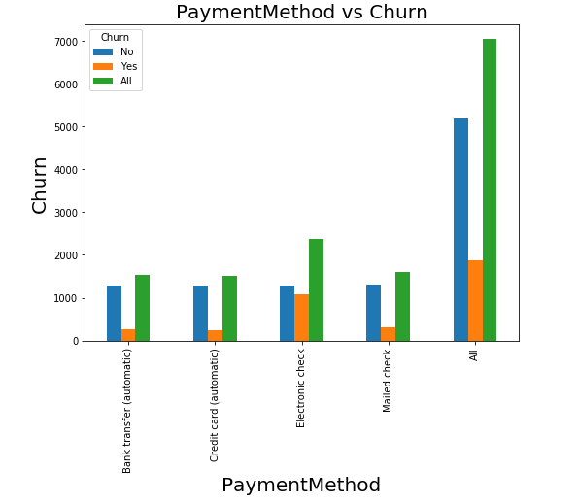

Insight.
The percentage of automatic Bank transfer clients that left is 13.8%
The percentage of clients that were using an automatic credit card for their transactions that left is 12.4%.
The percentage of clients that used an electronic check that left is 57.3%.
The percentage of clients that used Mail check that left is 16.47%
From the chart above, it shows that customers that used automated payments are more retain-able as compared to other payment methods.
Recommendations.
The company should automate other payment methods too.

The Graph of Tech Support against Churn
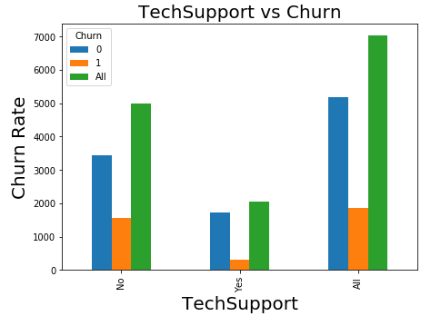

The percentage of clients that was rendered no Technical Support that churned is 77.36%.
The percentage of clients that were rendered with Technical Support that churned 16.58%.
From the chart above it shows that customers with no technical support are most likely to leave the service or company.

Recommendations.
The company should find out all customers without technical support and start providing them with technical support.

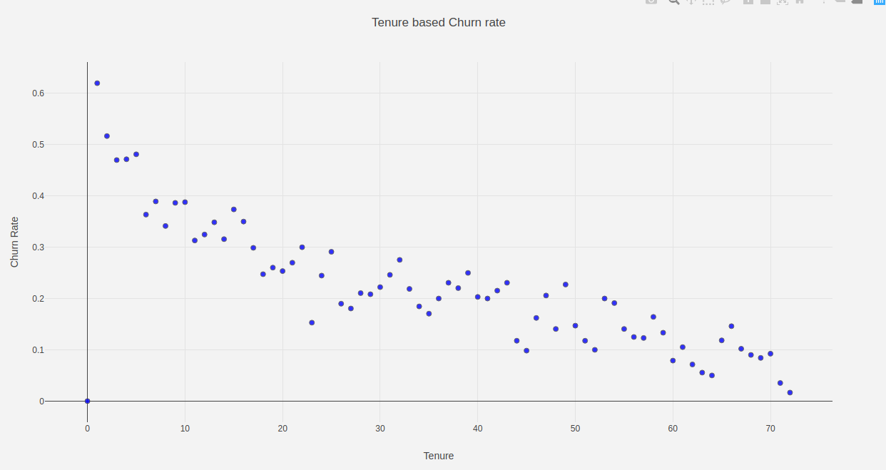

The graph above shows that Tenure is indirectly proportional to Churn.

Recommendations
The company should resolve means of retaining its clients for a long time. The longer the tenure the lesser the churn.

